Project Sprint 1

# Property 1

Property 1 holds. It is possible to transmit all of the data in the sender’s buffer to the receiver’s buffer. A trace of a successful instance is detailed below.

## State 0

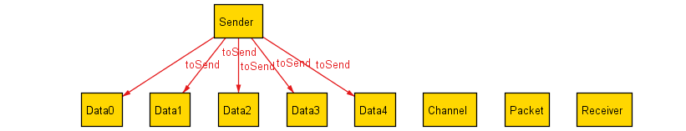

Our model contains a Sender which contains all of the data to be sent, a Receiver which contains all of the data that has been received, and a Channel which contains all of the data that is being transmitted. During transmission, Data is wrapped in a Packet. In the initial state, all of the data is held by the Sender. No data has been received and no data is being transmitted.

## State 1

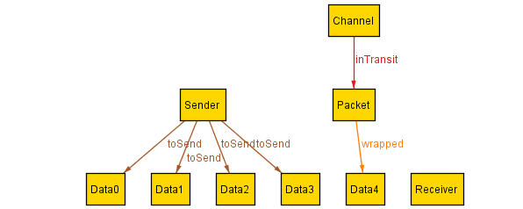

In this state, Data4 is being transmitted. The Data is wrapped in a Packet, which is being transmitted through the Channel. Data4 is no longer in Sender’s list of data to be sent.

## State 2

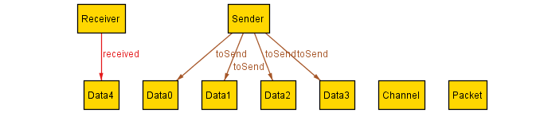

In this state, Data4 has been received. Data4 is no longer wrapped in a Packet or in a Channel.

## State 3

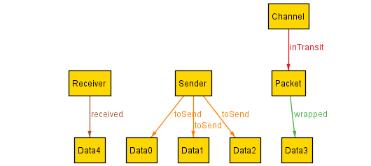

The sending process repeats itself. This time Data3 is being sent.

## State 4

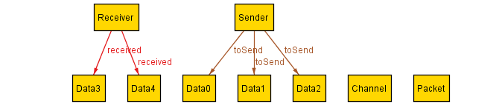

The receiving process repeats itself. Data3 has been received.

## State 5

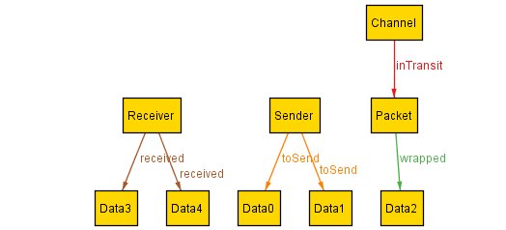

Data2 is being sent.

## State 6

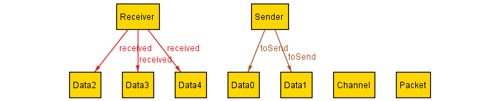

Data2 is received.

## State 7

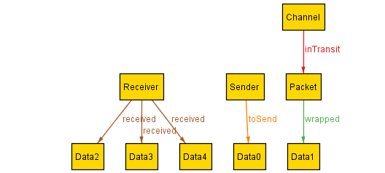

Data1 is being sent.

## State 8

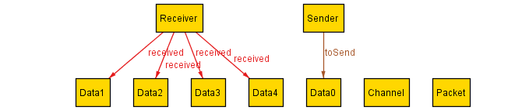

Data1 is received.

## State 9

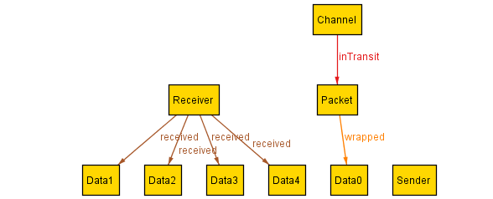

Data0 is being sent. All of the data has now been sent, so Sender’s list of Data to be sent is now empty.

## State 10

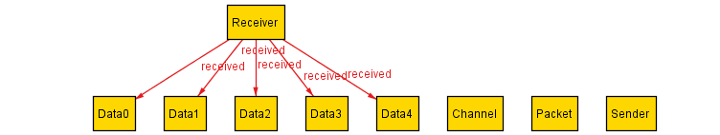

Data0 is received. All of the Data has now been received.

# Property 2

No instance of a failing case was found. Thus the second property holds: it is always possible to transmit all of the data in the sender’s buffer to the receiver’s buffer.

